**Indian Medical Association, Serampore Branch**

(Registered Under W.B. Societies Registration Act. XXVI of 1961)

**Regd. No. : S/2L/64263 of 2017-2018**

131/B, Patua Para Lane, Serampore, Hooghly-712201, West Bengal, India

**Ph: 2652-6083, E-mail** : imaserampore@gmail.com,, **Website: www.imaserampore.org**

………………………………………………………………………………………………………

**SECRETARY’s REPORT FOR THE YEAR 2018-19**

**Regarding the main activities performed on behalf of Indian Medical Association, Serampore Branch during the last 1 year, we have undertaken several health awareness programmes such as Mother and Child Health programme, adolescence problems awareness programme in schools and colleges, Cancer detection camps, Dermatological camps, Diabetic detection camps etc. in urban areas. From April 2018 to March 2019, we have organized Health check up camps in schools and voluntary organizations. On 7th April, 2018 at Serampore Mission Girls High School, World Health Day was observed on behalf of Indian Medical Association, Serampore Branch in association with Rajdeep Yoga and Cultural Society where Dr. Pradip Kumar Das, President of the Branch spoke on the importance of the Day and by 2030 Health for all and every where and for every body as voiced by a Clarion call by World Health organization by ensuring protective, curative, technological, palliative and improving infrastructural health facilities to all including priority  to the underprivileged communities. After Dr Das, Mr. Sudipta Biswas, Secretary of Rajdeep Yoga demonstrated some Yogasana for the fitness and wellness of our body**. **On 8th April, 2018, on the occasion of World Health Day, a Health Check up camp was organized on behalf of IMA, Serampore Branch for the aged persons at the premises of Serampore Pravin Samaj where more than 50 aged persons attended the camp for their Blood Sugar, Blood Pressure, ECG and others check up which was done by our doctor members. On 21st June international Yoga day was observed at Serampore Mission Girls’ High School where speeches were delivered by Dr. Pradip Kumar Das, President of IMA, Serampore Branch and Mr. Sudipta Biswas, Yoga Teacher of Rajdeep Yoga and culture Society. On 1st July, 2018 at the premises of Serampore IMA Bhavan, a voluntary Blood donation camp was organized by IMA Serampore Branch along with Swasthya Bhabna Welfare Society where 36 donors including 7 female donors donated their blood. On 8th July, Mega Health Check up camp was organized by IMA, Serampore Branch in collaboration with Swasthya Bhabna Welfare Society at the premises of Sugran-Abhijnan of Serampore where more than 200 patients attended the camp for check up for Blood Pressure measurement, ECG, Blood Sugar estimation, BMD camp, Eye check up, Heart check up, Uroflometry test, Thyroid Function and Skin and Hair testing. International Women's Day was observed on behalf of Indian Medical Association, Serampore Branch on 8th March, 2019 at Serampore IMA Bhavan where more than 60 eminent personalities attached to different professions were present and felicitated on behalf of the organization. A sangeet Album was inaugurated by the Eminent Women participants.  After that a dance programme on Ritu Ranga was performed by the students and teachers of Viswabharati University. A Website in the name of** [**www.imaserampore.org**](http://www.imaserampore.org) **was opened for displaying our activities in the Social Media. A Project on Community Radio Station (CRS) at our premises was placed to the Broadcasting Dept. of Govt. of India for approval, preliminary enquaries were done and we are waiting for the final approval.**

**Many works were done with the help of our members but there are many things to be undone. But we have a dream to reach to them for the fulfillment of our mission.**

**With great wishes and thank to all,**

**Dr. Abhijnan Ghosh**

**Secretary**

**Indian Medical Association, Serampore Branch**

**ACTIVITIES OF IMA, SERAMPORE BRANCH FOR THE YEAR 2018-19**

**STARTING FROM 1ST APRIL, 2018 TO 31ST MARCH,2019**

|  |  |  |  |  |
| --- | --- | --- | --- | --- |
| **1** | **IMA Bhavan** | **01.4.18** | **Scientific Discussion on "Management of Ankyalysing Spondyalitis and Psoriatic Artharitis", delivered by Dr Dibyendu Mukherjee, Consultant Physician** | **32** |
| **2** | **Serampore Mission Girls’ High School** | **07.04.2018** | **Observance of World Health Day by arranging a Socio-Medical Seminar on accessibility of health services to all** | **450** |
| **3** | **IMA Bhavan** | **22.04.2018** | **3rd E.C. meeting on** | **14** |
| **4** | **IMA Bhavan** | **29th April, 2018** | **Annual General Meeting (AGM) on 29th April, 2018** | **52** |
| **5** | **IMA Bhavan** | **29th April, 2018** | **Scientific Discussion on "New Development of Cancer Surgery", delivered by Dr Samindra Nath Basak, Consultant Oncosurgeon, AMRI** | **52** |
| **6** | **IMA Bhavan** | **06.05.2018** | **4th Annual Conference of IMA, Serampore Branch, SIMACON-18** | **130** |
| **7** | **IMA Bhavan** | **3rd June,2018** | **Inaugural ceremony of Old Age Treatment cum Counseling Clinic named as Barannya Bardhyakka Parisebha** | **150** |
| **8** | **Serampore Mission girls’ High School** | **21st June,2018** | **Observance of International Yoga Day** | **350** |
| **9** | **IMA Bhavan** | **24th June,2018** | **Health check up camp for the aged persons** | **50** |
| **10** | **IMA Bhavan** | **24th June,2018** | **4th E.C. meeting on 24th June 2018** | **09** |
| **11** | **IMA Bhavan** | **1st July, 2018** | **Voluntary Blood Donation Camp and felicitation of Senior Doctor Members of our branch** | **36 Donated blood**  **7 Doctor Members felicited** |
| **12** | **IMA Bhavan** | **1st July, 2018** | **Scientific Discussion on "UTI Management & recent management of Overactive Bladder ", to be delivered by Dr Mollinath Mukherjee, Consultant Urolologist** | **30** |
| **13** | **Surangan-Abhijnan premises** | **8th July, 2018** | **Mega Health Check up camp along with Blood sugar, ECG, Uric Acid, BMD, Eye check and skin check up etc.** | **150** |
| **14** | **IMA Bhavan** | **12 th August, 2018** | **CME on "Advance Management on UTI & Day to Day Urological Practice ", to be delivered by Dr Puskar Shyam Chowdhury, Consultant Urologist, Fortis Hospital, Kolkata** | **27** |
| **15** | **IMA Bhavan** | **12 th August, 2018** | **5th E.C. meeting on 12th August 2018** | **07** |
| **16** | **IMA Bhavan** | **8th September,18** | **A condolence meeting on 8th September, 2018 to show our respect to departed soul of Dr. Gurudas Basak who passed away from this earth on 29.08.2018, the** | **15** |
| **17** | **IMA Bhavan** | **9th September,18** | **Scientific Discussion on "Advance Management of Exacerbation of Bronchial Asthma " delivered by Dr Angshuman Mukherjee, Pulmologist, Fortis Hospital, Kolkata** | **32** |
| **18** | **IMA Bhavan** | **28.10.2018** | **Bijoya Sammelan on Sunday the 28th October, 2018** | **90** |
| **19** | **IMA Bhavan** | **11th November2018** | **Scientific Discussion on "Prevention of infection in ICU’’, delivered by Dr Kausik Dutta, Consultant Physician, Uttarpara, and on Evidence based lifestyle modification by Dr. Rajarshi Roy, Consultant Physician, Dept. of Critical Care, AMRI, Salt Lake on Sunday the 11th November, 2018** | **35** |
| **20** | **IMA Bhavan** | **25th November 2018** | **Scientific Discussion on "Baby Health Care & Management of Dehydration’’ delivered by Dr Somen Sur, Consultant Paediatrician, Serampore on Sunday the 25th November, 2018** | **32** |
| **21** | **IMA Bhavan** | **6th December 2018** | **6th E.C. meeting** | **10** |
| **22** | **IMA Bhavan** | **15th December,2018** | **Mega Health check up camp for the aged persons** | **100** |
| **23** | **IMA Bhavan** | **25th December 2018** | **Baby Health Check up and Baby Health Show competition** | **200** |
| **24** | **Hansansari Mandir premises** | **30th December,2018** | **Get together** | **65** |
| **25** | **IMA Bhavan** | **24th February 2019** | **8th E.C. meeting** | **10** |
| **26** | **IMA Bhavan** | **8th March, 2019** | **Observance of International Women’s Day** | **100** |
| **27** | **IMA Bhavan** | **15, 16. 17th**  **March,**  **2019** | **Organization of 3Days Workshop cum Seminar on Health, Hygiene, Nutrition and First Aid in collaboration with NSS Serampore College & Serampore Girls’ College** | **100** |
| **28** | **IMA Bhavan** | **23rd March, 2019** | **Mega Health Check up camp for the aged persons through Barannya Bardhayaka Parisebha** | **65** |
| **29** | **IMA Bhavan** | **24th March, 2019** | **9th E.C. Meeting** | **10** |
|  |  |  |  |  |
|  |  |  |  |  |
|  |  |  |  |  |
|  |  |  |  |  |

**OBSERVANCE OF INTERNATIONAL WOMEN’S DAY ON BEHALF OF**

**IMA, SERAMPORE BRANCH**

International Women's Day was observed on behalf of Indian Medical Association, Serampore Branch on 8th March, 2019 at Serampore IMA Bhavan where more than 60 eminent personalities attached to different professions were present and felicitated on behalf of IMA Serampore Branch. On behalf of IMA, Serampore Branch , President, Dr. Pradip Kumar Das welcome all the eminent personalities present in the programme and spoke on a lucent voice the importance of observation of this day. On this occasion, a Dance programme on Ritu Ranga was staged by the Students and Teachers of Viswabharati University which was highly appreciated by the audience. The whole programme was conducted by Dr. Pradip Kumar Das.

Dr.P.K.Das

President, IMA, Serampore Branch.

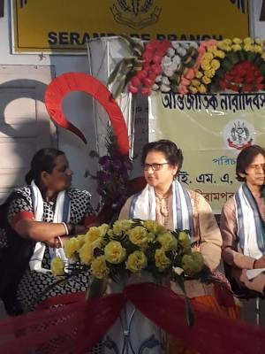

O.C OF SERAMPORE WOMEN POLICE STATION

& DR. SUMIT BASU, PROFESSOR OF VISWABHARATI UNIVERSITY

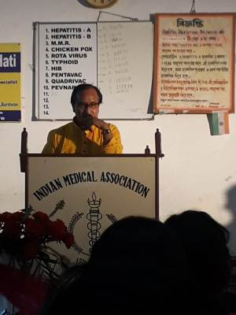

DR. PRADIP KUMAR DAS, PRESIDENT OF IMA SERAMPORE BRANCH

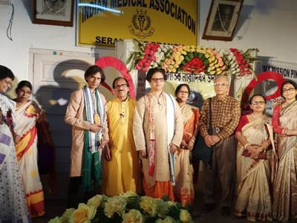

EMINENT PERSONALITIES PRESENT IN THE PROGRAMME

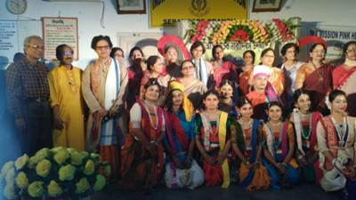

**ACTIVITIES OF IMMUNISATION CLINIC OF IMA, SERAMPORE BRANCH DURING THE PERIOD FROM 1ST APRIL 2018 TO 31ST MARCH, 2019**

|  |  |  |  |
| --- | --- | --- | --- |
| **TYPE OF VACCINE** | **TOTAL NO.OF RECEPIENTS**  **(1st April,2018 to 31 st March 19)** | **TOTAL NO.OF CHILDREN ATTENDING IMMUNISATION CLINIC DURING THE PERIOD**  **9143** | **TOTAL NO. OF CHILDREN ATTENDING CHILD CLINIC DURING THE PERIOD**  **406** |
|  |  |
| **O POLIO & BCG** | **182** |  |  |
| **DPT** | **1759** |  |  |
| **POLIO** | **2009** |  |  |
| **MEASLES** | **278** |  |  |
| **HEPATITIS B (CHILD)** | **694** |  |  |
| **HEPATITIS B (ADULT)** | **14** |  |  |
| **DT** | **10** |  |  |
| **HIB** | **95** |  |  |
| **MMR** | **501** |  |  |
| **TYPHOID** | **1111** |  |  |
| **CHICKENPOX** | **274** |  |  |
| **HEPATITIS-A** | **438** |  |  |
| **TD** | **271** |  |  |
| **ROTARIK** | **438** |  |  |
| **PENTAVALENT** | **340** |  |  |
| **QUADRIVAC** | **576** |  |  |
| **P.C.V** | **153** |  |  |

**MEMBERSHIP UPTO 31ST MARCH 2019**

|  |  |  |  |  |  |  |
| --- | --- | --- | --- | --- | --- | --- |
| **Ordinary**  **Member** | **Life Member** | **IMACGP** | **IMAAMS** | **SSS** | **Service**  **Doctors** | **Women**  **Doctors** |
| **54** | **76** | **01** | **01** | **-** | **-** | **-** |

**No. of General Body Meeting held: 01**

**Date and No of Members attended : 29.04.2018, - 52 in AGM**

**No. of E.C. Meeting held –09 attendance – Average attendance -10**